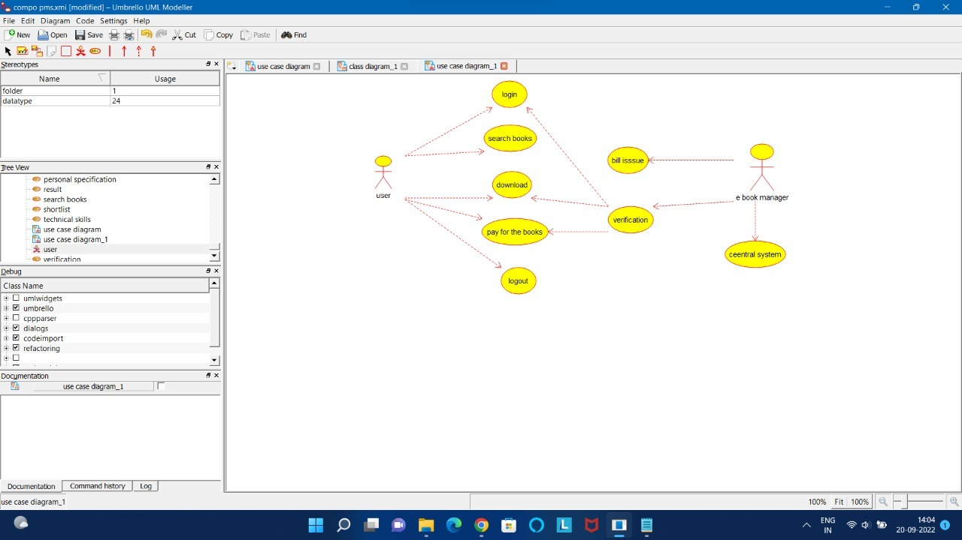

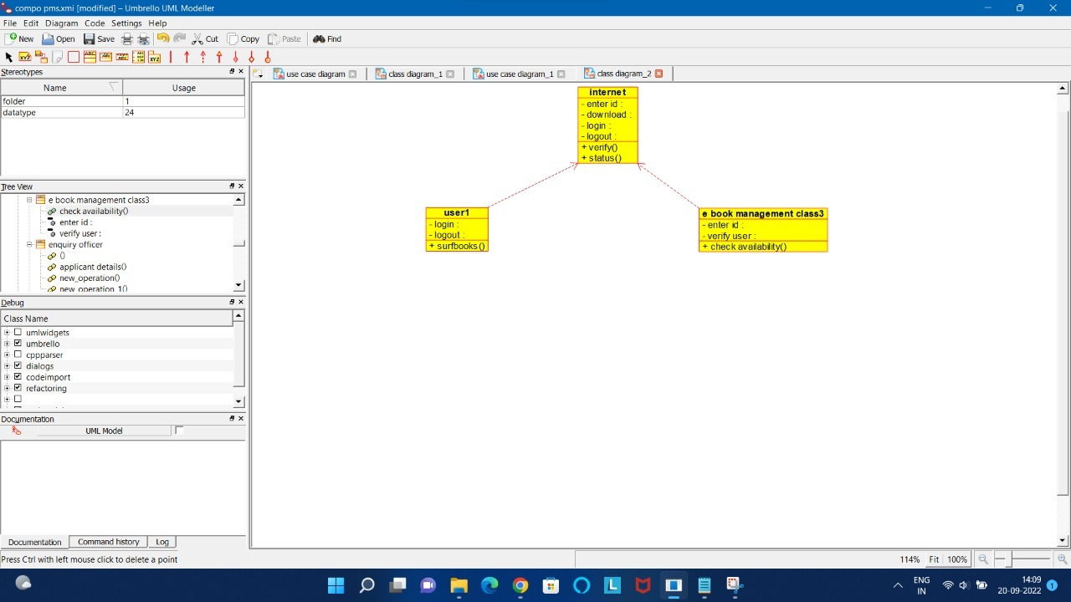

/**

* Class e_book_management_class3

*/

public class e_book_management_class3 {

//

// Fields

//

private void enter_id;

private void verify_user;

//

// Constructors

//

public e_book_management_class3 () { };

//

// Methods

//

//

// Accessor methods

//

/**

* Set the value of enter_id

* @param newVar the new value of enter_id

*/

private void setEnter_id (void newVar) {

enter_id = newVar;

}

/**

* Get the value of enter_id

* @return the value of enter_id

*/

private void getEnter_id () {

return enter_id;

}

/**

* Set the value of verify_user

* @param newVar the new value of verify_user

*/

private void setVerify_user (void newVar) {

verify_user = newVar;

}

/**

* Get the value of verify_user

* @return the value of verify_user

*/

private void getVerify_user () {

return verify_user;

}

//

// Other methods

//

/**

*/

public void check_availability()

{

}

}

/**

* Class internet

*/

public class internet {

//

// Fields

//

private void enter_id;

private void download;

private void login;

private void logout;

//

// Constructors

//

public internet () { };

//

// Methods

//

//

// Accessor methods

//

/**

* Set the value of enter_id

* @param newVar the new value of enter_id

*/

private void setEnter_id (void newVar) {

enter_id = newVar;

}

/**

* Get the value of enter_id

* @return the value of enter_id

*/

private void getEnter_id () {

return enter_id;

}

/**

* Set the value of download

* @param newVar the new value of download

*/

private void setDownload (void newVar) {

download = newVar;

}

/**

* Get the value of download

* @return the value of download

*/

private void getDownload () {

return download;

}

/**

* Set the value of login

* @param newVar the new value of login

*/

private void setLogin (void newVar) {

login = newVar;

}

/**

* Get the value of login

* @return the value of login

//*

* Class internet

private void getLogin () {/**

*/

* Class internet

return login;

public class internet {

//*

}

public class internet {

* Class internet/**

//

*/

* Class internet

// Fields

public class internet {

//

*/

/**

//

// Fields

public class internet {

* Set the value of logout

//

//

* @param newVar the new value of logout

// Fields

//

private void enter_id;

*/

//

// Fields

private void download;

private void enter_id;

private void setLogout (void newVar) {

//

private void login;

private void download;

logout = newVar;

private void enter_id;

private void logout;

private void login;

}

private void download;

private void enter_id;

private void logout;

private void login;

private void download;

//

/**

private void logout;

private void login;

// Constructors

//

* Get the value of logout

private void logout;

//

// Constructors

* @return the value of logout

//

public internet () { };

//

*/

// Constructors

//

public internet () { };

private void getLogout () {

//

// Constructors

//

return logout;

public internet () { };

//

// Methods

//

}

public internet () { };

//

// Methods

//

//

//

// Methods

//

// Other methods

//

// Methods

//

//

//

// Accessor methods

//

//

// Accessor methods

/**

//

//

*/

// Accessor methods

//

/**

public void verify()

//

// Accessor methods

* Set the value of enter_id

/**

{

//

* @param newVar the new value of enter_id

* Set the value of enter_id

}

/**

*/

* @param newVar the new value of enter_id

* Set the value of enter_id

/**

private void setEnter_id (void newVar) {

*/

* @param newVar the new value of enter_id

* Set the value of enter_id

enter_id = newVar;

private void setEnter_id (void newVar) {

/**

*/

* @param newVar the new value of enter_id

}

enter_id = newVar;

*/

private void setEnter_id (void newVar) {

*/

}

public void status()

enter_id = newVar;

private void setEnter_id (void newVar) {

/**

{

}

enter_id = newVar;

* Get the value of enter_id

/**

}

}

* @return the value of enter_id

* Get the value of enter_id

/**

*/

* @return the value of enter_id

* Get the value of enter_id

/**

private void getEnter_id () {

*/

}

* @return the value of enter_id

* Get the value of enter_id

return enter_id;

private void getEnter_id () {

*/

* @return the value of enter_id

}

return enter_id;

private void getEnter_id () {

*/

}

return enter_id;

private void getEnter_id () {

/**

}

return enter_id;

* Set the value of download

/**

}

* @param newVar the new value of download

* Set the value of download

/**

*/

* @param newVar the new value of download

* Set the value of download

/**

private void setDownload (void newVar) {

*/

* @param newVar the new value of download

* Set the value of download

download = newVar;

private void setDownload (void newVar) {

*/

* @param newVar the new value of download

}

download = newVar;

private void setDownload (void newVar) {

*/

}

download = newVar;

private void setDownload (void newVar) {

/**

}

download = newVar;

* Get the value of download

/**

}

* @return the value of download

* Get the value of download

/**

*/

* @return the value of download

* Get the value of download

/**

private void getDownload () {

*/

* @return the value of download

* Get the value of download

return download;

private void getDownload () {

*/

* @return the value of download

}

return download;

private void getDownload () {

*/

}

return download;

private void getDownload () {

/**

}

return download;

* Set the value of login

/**

}

* @param newVar the new value of login

* Set the value of login

/**

*/

* @param newVar the new value of login

* Set the value of login

/**

private void setLogin (void newVar) {

*/

* @param newVar the new value of login

* Set the value of login

login = newVar;

private void setLogin (void newVar) {

*/

* @param newVar the new value of login

}

login = newVar;

private void setLogin (void newVar) {

*/

}

login = newVar;

private void setLogin (void newVar) {

/**

}

login = newVar;

* Get the value of login

/**

}

* @return the value of login

* Get the value of login

/**

*/

* @return the value of login

* Get the value of login

/**

private void getLogin () {

*/

* @return the value of login

* Get the value of login

return login;

private void getLogin () {

*/

* @return the value of login

}

return login;

private void getLogin () {

*/

}

return login;

private void getLogin () {

/**

}

return login;

* Set the value of logout

/**

}

* @param newVar the new value of logout

* Set the value of logout

/**

*/

* @param newVar the new value of logout

* Set the value of logout

/**

private void setLogout (void newVar) {

*/

* @param newVar the new value of logout

* Set the value of logout

logout = newVar;

private void setLogout (void newVar) {

*/

* @param newVar the new value of logout

}

logout = newVar;

private void setLogout (void newVar) {

*/

}

logout = newVar;

private void setLogout (void newVar) {

/**

}

logout = newVar;

* Get the value of logout

/**

}

* @return the value of logout

* Get the value of logout

/**

*/

* @return the value of logout

* Get the value of logout

/**

private void getLogout () {

*/

* @return the value of logout

* Get the value of logout

return logout;

private void getLogout () {

*/

* @return the value of logout

}

return logout;

private void getLogout () {

*/

}

return logout;

private void getLogout () {

//

}

return logout;

// Other methods

//

}

//

// Other methods

//

//

// Other methods

//

/**

//

// Other methods

*/

/**

//

public void verify()

*/

/**

{

public void verify()

*/

/**

}

{

public void verify()

*/

}

{

public void verify()

}

{

/**

}

*/

/**

public void status()

*/

/**

{

public void status()

*/

/**

}

{

public void status()

*/

}

{

public void status()

}

{

}

}

}

}

}

/**

* Class user1

*/

public class user1 {

//

// Fields

//

private void login;

private void logout;

//

// Constructors

//

public user1 () { };

//

// Methods

//

//

// Accessor methods

//

/**

* Set the value of login

* @param newVar the new value of login

*/

private void setLogin (void newVar) {

login = newVar;

}

/**

* Get the value of login

* @return the value of login

*/

private void getLogin () {

return login;

}

/**

* Set the value of logout

* @param newVar the new value of logout

*/

private void setLogout (void newVar) {

logout = newVar;

}

/**

* Get the value of logout

* @return the value of logout

*/

private void getLogout () {

return logout;

}

//

// Other methods

//

/**

*/

public void surfbooks()

{

}

}